**🛠️ Step-by-Step Setup: AWS-Based Receipt Automation Pipeline**

This walkthrough will help you build a serverless receipt processing system using AWS tools from start to finish.

**1️⃣ Set Up Amazon S3 Bucket (for receipt uploads)**

**✅ Instructions:**

1. Go to S3 Console → Click "Create Bucket"
2. Choose your region (e.g., ap-south-1)
3. Give it a name (e.g., scanvault-storage-kartik07)
4. Click "Create bucket"
5. Inside the bucket, create a folder (e.g., scanvault-incoming/) for organized uploads

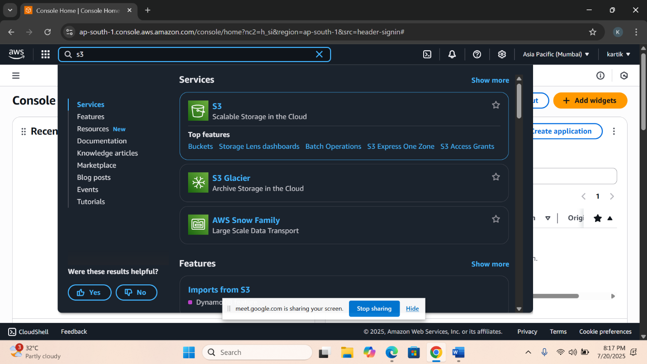

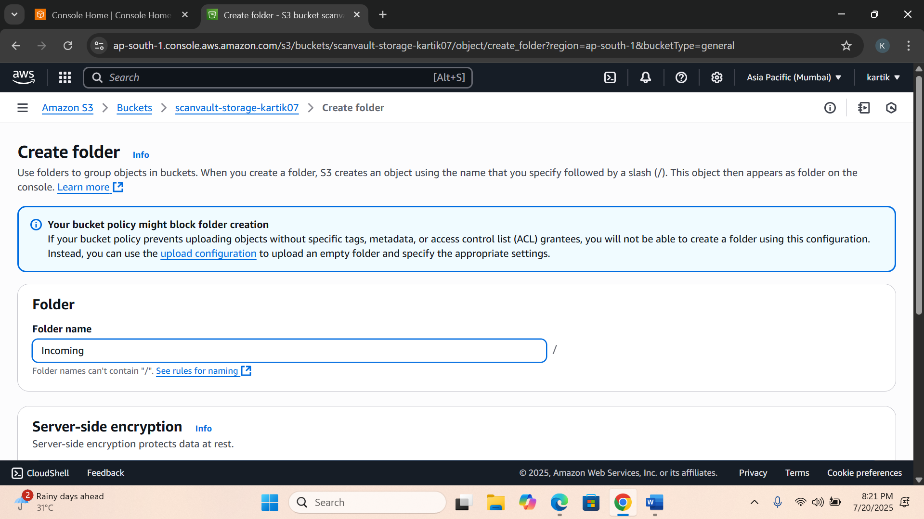

**2️⃣ Configure DynamoDB Table (for storing extracted data)**

**✅ Instructions:**

1. Navigate to DynamoDB Console → Click "Create Table"
2. Table Name: ScanVault-Receipts-Table
3. Set Partition Key as receipt_id (Type: String)
4. Set Sort Key as date (Type: String)
5. Click "Create"

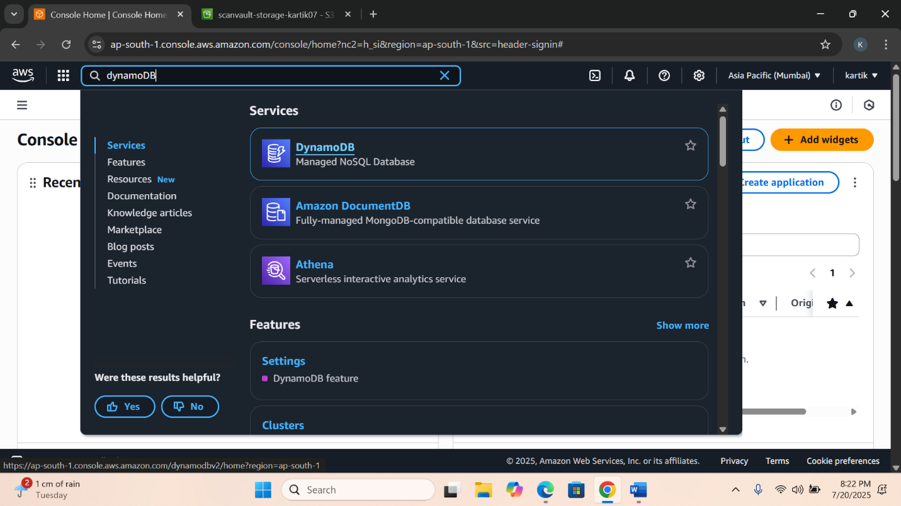

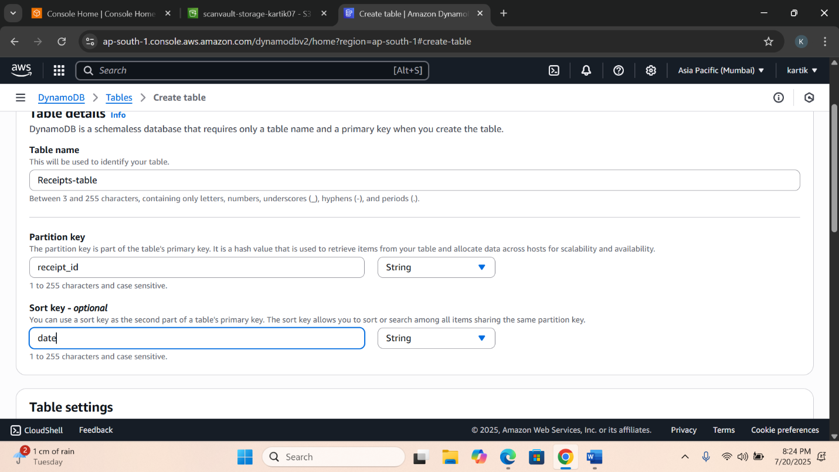

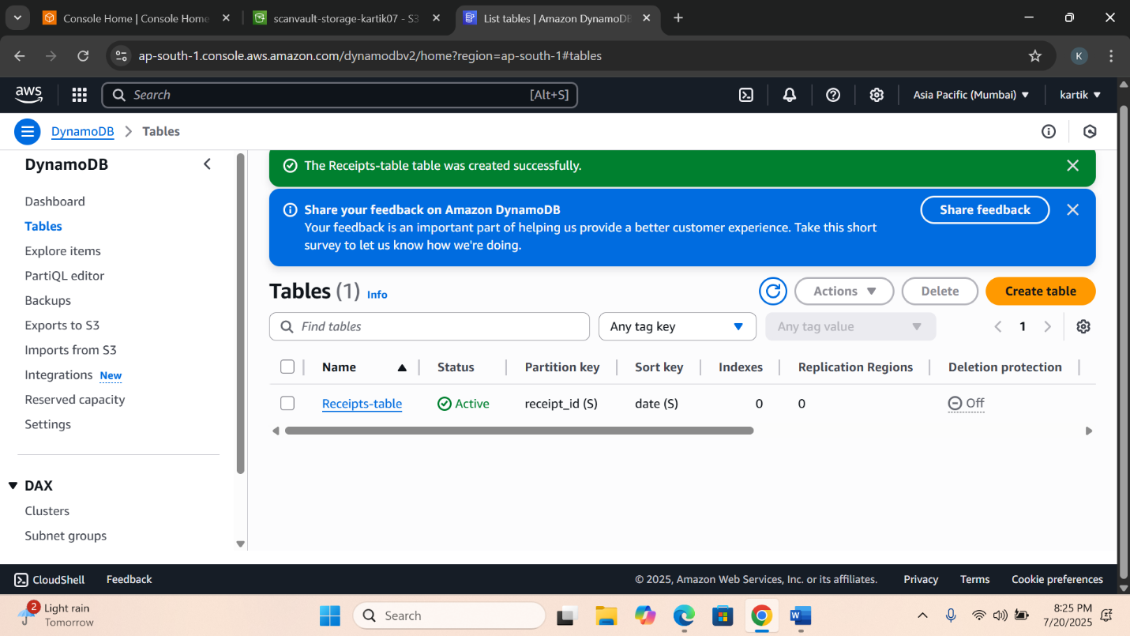

**3️⃣ Setup Amazon SES (for email alerts)**

**✅ Instructions:**

1. Open Amazon SES Console
2. Under Verified Identities, verify your sender email
3. If your account is in sandbox mode, also verify recipient email
4. Note the selected region (e.g., ap-south-1) for Lambda usage
5. 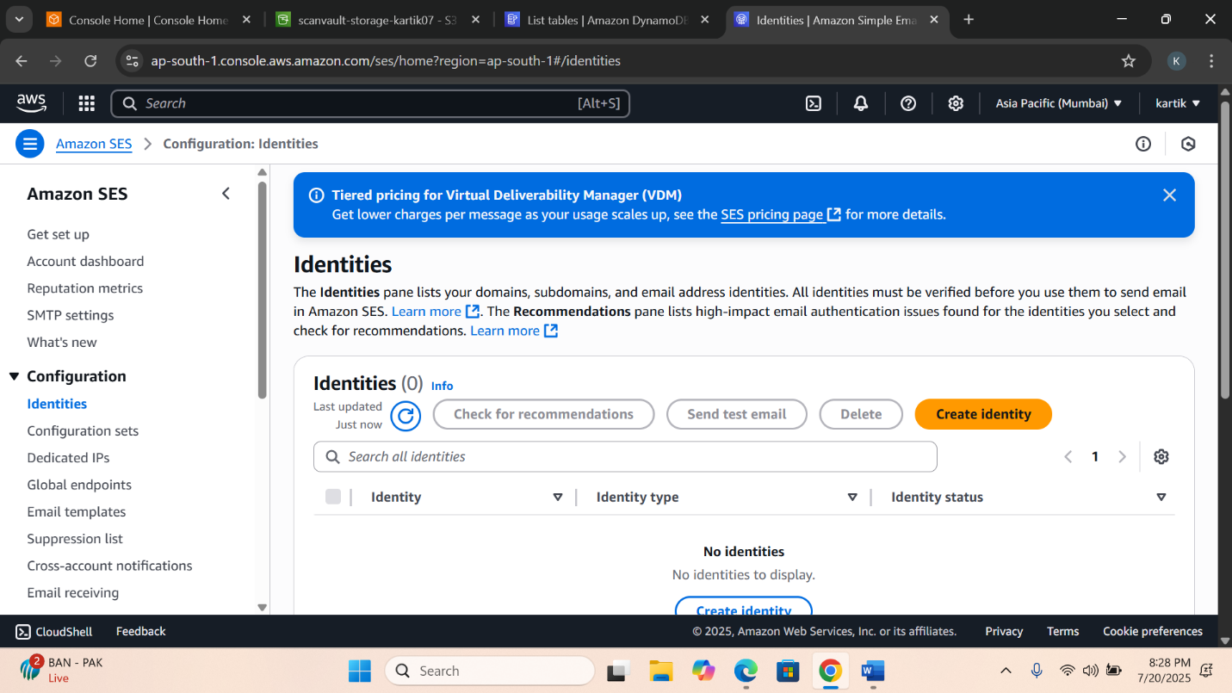

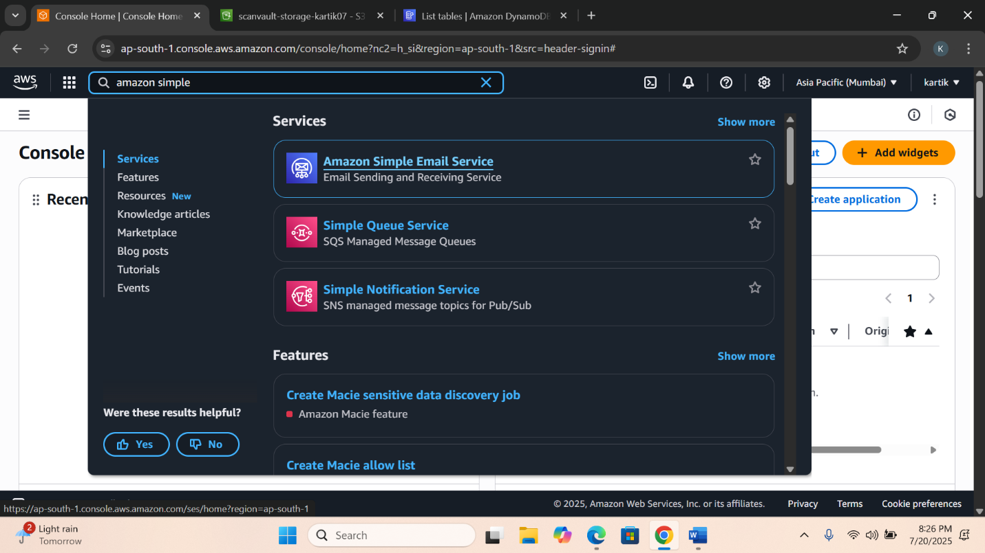

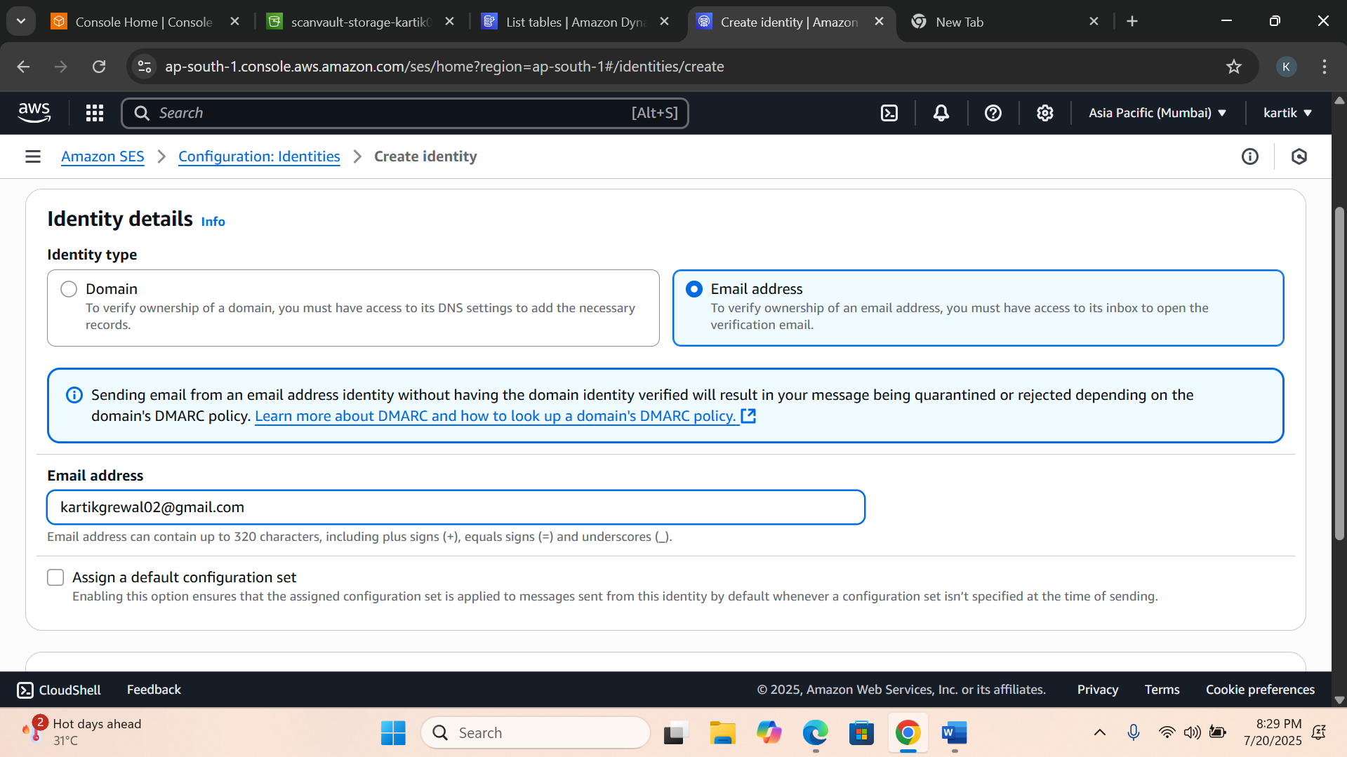

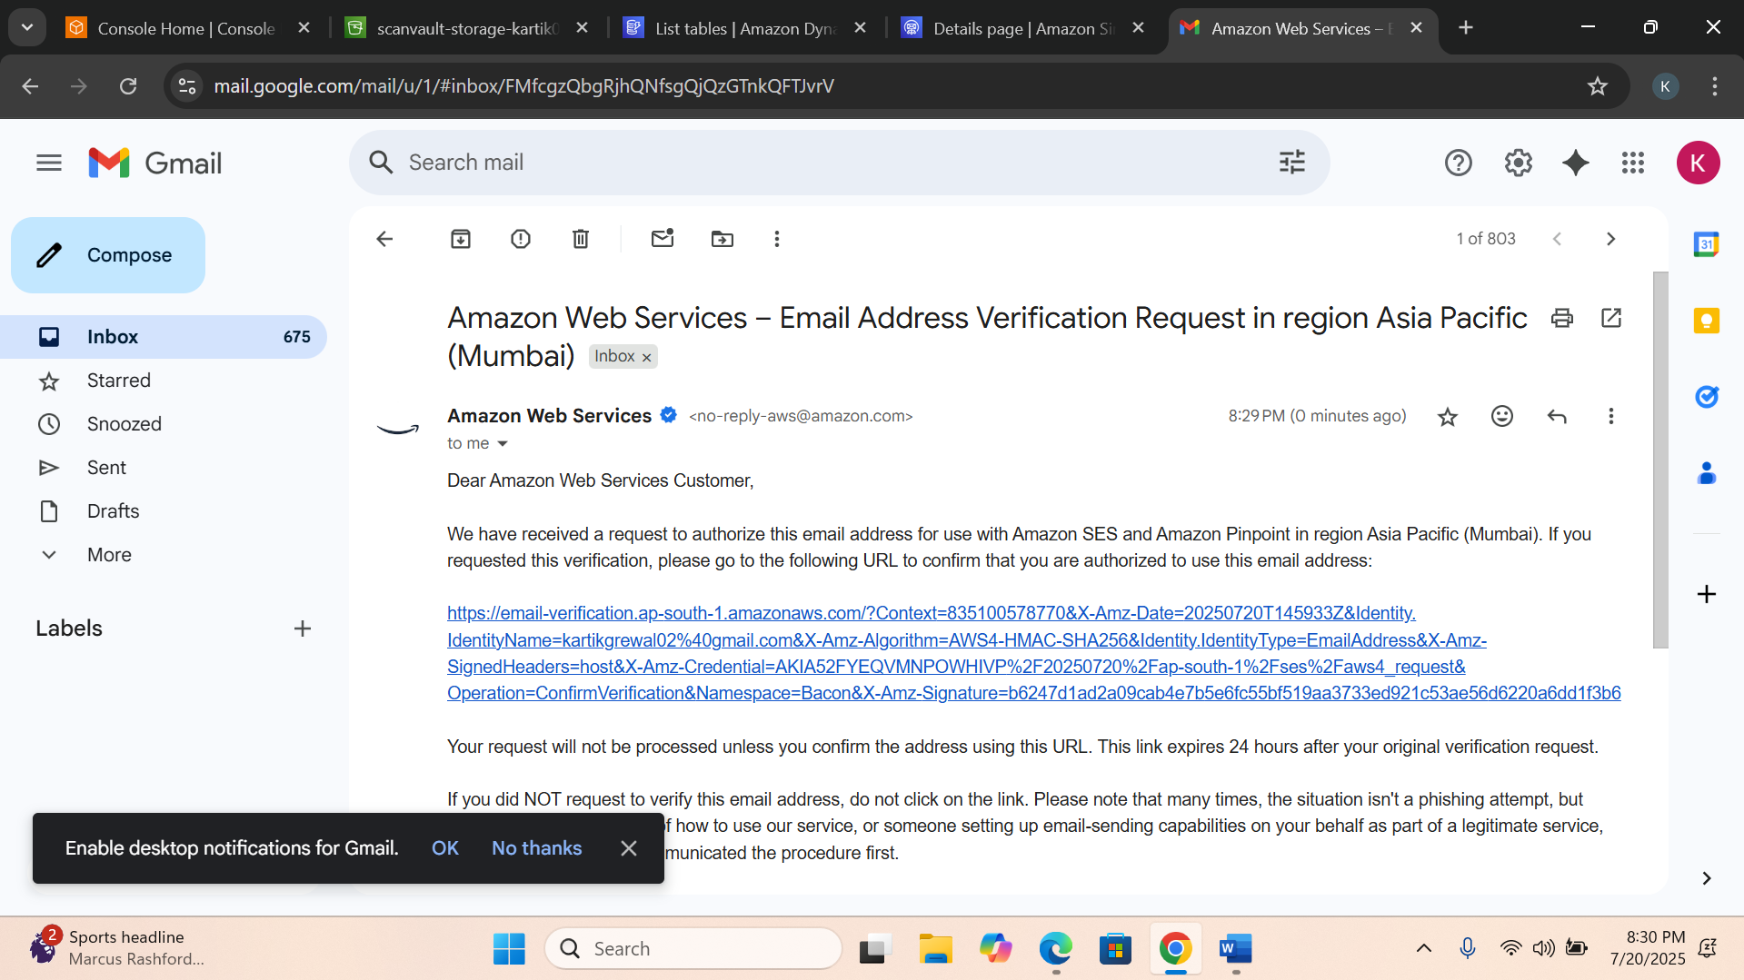

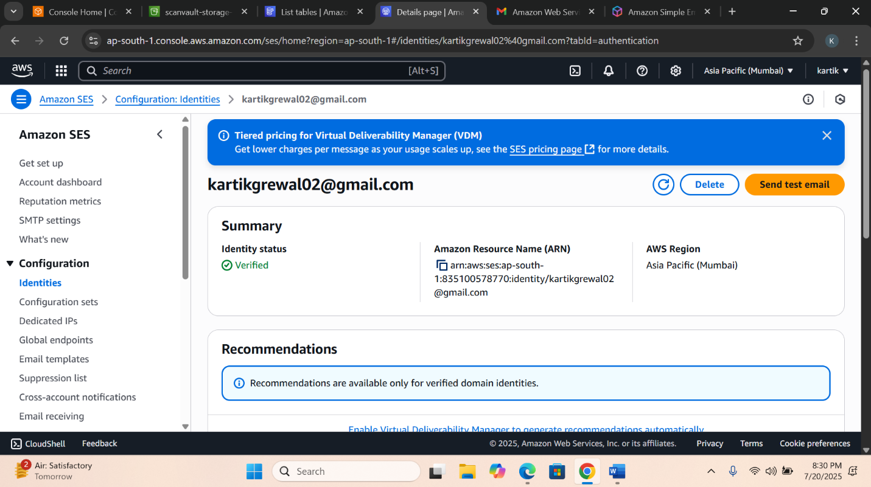

**4️⃣ Create IAM Role for Lambda (permissions handler)**

**✅ Instructions:**

1. Go to IAM Console → Click Roles → Create Role
2. Choose Lambda as the use case
3. Attach the following policies:
   * AmazonS3ReadOnlyAccess
   * AmazonTextractFullAccess
   * AmazonDynamoDBFullAccess
   * AmazonSESFullAccess
   * AWSLambdaBasicExecutionRole
4. Name the role: ScanVault-lambdrole

